BlazeVideo HDTV Player v6.0
User’s Manual

Table of Contents

Ⅰ. Overview 2
1.1 Introduction 2
1.2 Features 2
1.3 System Requirements 3
Ⅱ. Appearance & Menus 3
Ⅲ. Operation Guide 5
3.1 Scan Channels 5
3.2 Watch Live TV Show 6
3.3 Display Teletext 7
3.4 Receive FM Radio 7
3.5 TimeShift 7
3.6 Program Guide 8
3.7 Live Record TV Show 8
3.8 Create Schedule Task 8
3.9 Schedule Record TV Show 9
3.10 Reminded to Watch 9
3.11 Multi-channel Preview 9
3.12 Favorite Management 10
3.13 Take Snapshot 11
Ⅳ. Settings 12
4.1 DTV Setting 12
4.2 Record Setting 13
Ⅴ. Technical Support 13
5.1 Troubleshooting 13
5.2. Contact Support 14

Ⅰ. Overview

1.1 Introduction
BlazeVideo HDTV Player is a full-featured but easy to use HDTV player for you to watch, record, pause, replay live TV, Teletext and FM radio on PC. Compliant with both Analog (PAL, NTSC, SECAM) and Digital (DVB-T, DVB-S, ATSC) TV standard, it supports most popular TV Card with BDA interface on market.
BlazeVideo HDTV Player also acts as your multi-media center with superior video and audio quality, supporting DVD and most popular media files playback. The more advanced features, such as DVD record/ bookmark, video capture, photo slideshow, special audio effect, bring you an infinite wonderful multi-media entertainment.

1.2 Features
- Wide compatibility, support both Analog (PAL, NTSC, SECAM) and Digital (DVB-T, DVB-S, ATSC) TV standard;
- Watch, record, pause, replay analog or digital live TV, Teletext and FM radio
- Intelligent EPG guides you through what and when to watch
- TimeShift to pause live TV shows for a break or skip commercial
- Smart search to quickly locate favorite TV shows or desired TV Show time
- Search filter helps to display program by time, by type: TV or Radio, Free to Air or Scrambled
- Real-time record while watching live TV show
- Schedule record, never miss any wonderful TV shows
- Remind to watch at scheduled time
- Auto & manually scan all available channels
- Display subtitle, support multiple language & audio channels
- Capture TV show/DVD video as still image
- Freely manage favorites channels
- Multi-channel preview to quickly access favorite programs
- Full-featured media center, play DVD/SVCD/VCD/CD disc and most popular media files with outstanding video & audio quality
- Smart Stretch lets video smart fit on all monitor, avoid video loss or distortion
- DVD video/audio record and DVD bookmark preview
- Advanced power saving scheme for Notebook PC
- Auto wakeup to perform schedule task at PC hibernation status

1.3 System Requirements
 | Basic
CPU | Intel Celeron 600MHz or higher
System Memory | 128MB RAM or higher
Operating System | Windows 98 SE/ME/ 2000/ XP/ Vista/7
Display Card | Have 24 Bits resolution and support DirectX, 8MB Video-ROM or more
Sound Card | PCI sound cards, Integration chipset on Mother Board, USB audio devices etc. compatible with Windows and stereo speakers
Device | All DVD drives;  HDTV receiver and its driver should be properly installed for HDTV playback
Hard-disk Available Capacity | At least 512 MB temporary space for TimeShifting;  Large enough space for HDTV/DVD record
DirectX | DirectX 9.0 or later

Ⅱ. Appearance & Menus
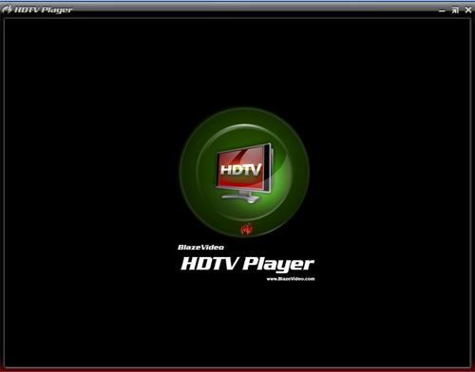

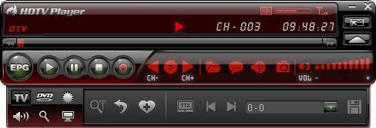

Button/Icon | Name | Description
 | EPG | Open HDTV EPG window
 | Play | Play HDTV or Media
 | TimeShift/Pause | TimeShift (for HDTV) or pause playback
 | Stop | Stop playback
 | Record | Record HDTV or DVD
 | Previous | Skip to play previous HDTV channel / DVD chapter
 | Browse | Browse channel
 | Next | Skip to play next HDTV channel / DVD chapter
 | Open | Select playback type
 | Subtitles | Select Subtitles
 | Audio | Select Audio
 | Capture | Capture video as .bmp still image
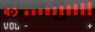 | Volume Control | Drag slider bar to adjust volume
 | Mute | Turn on/off audio
 | Media Type | Display playback type
 | Playback status | Display playback status
 | Signal Quality | Display HDTV signal quality
 | Signal Strength | Display HDTV signal strength
 | Channel/chapter | Display current HDTV channel / DVD chapter
 | Time | Display current time of HDTV / DVD
 | Fast backward | Fast backward, switch between 1X, 2X, 4X, 8X, 16X at each press
 | Slider bar | Drag the slider to new position for playback.
 | Fast Forward | Fast forward, switch between 1X, 2X, 4X, 8X, 16X at each press
 | Open Floating Panel | Show Floating Panel
 | Show Advanced Panel | Show/Hide Advanced Panel

Ⅲ. Operation Guide
BlazeVideo HDTV Player features very easy usage, below we just guide you through the HDTV operation, for DVD and medial files playback, please refer to the Help file attached with the software.

3.1 Scan Channels
3.1.1 Auto Scan Channels
If a HDTV device installed or connected to your PC, and its driver has been properly installed, after launch BlazeVideo HDTV Player, a box will pop up to enquire you whether to scan channels.
Click Yes, the "Scan" box ejects for you to set scan options.
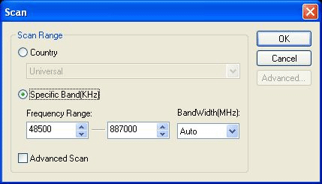
Advanced Setting: Check in "Advanced Scan" and click "Advanced..." to popup "Advanced Setting" box, here you can set advanced scan properties.
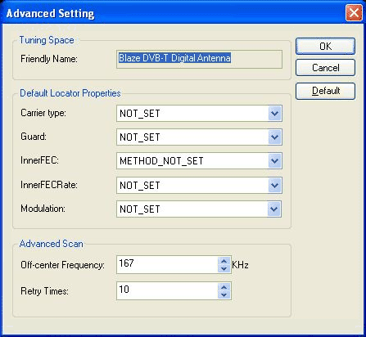
3.1.2 Manually Scan Channels
- In TV Advanced Panel click ;
- In EPG_Channels window click ;
- Go to Options-> DTV window, click "Scan" button under "DTV Source".
Abort Scanning:
Just press "Abort" button to stop scanning. (It is recommended you finish scanning one time at least).

3.2 Watch Live TV Show
Select Channel: In EPG_Channels window, double click a desired channel; or click to open channel list to select.
Switch Channel: click or to switch channel.
Browse Channel: Click to open channel list, all of the channels will be displayed.
Return to Last Channel: Click to resume play the last viewed channel.
Select Subtitle: Click to select your desired subtitle.
Select Audio: Click to select your desired audio.

3.3 Display Teletext
Note: The Teletext is activated only if HDTV service provider has provided such service.
Display Teletext:
- Click and tick "Teletext" in popup menu.
- Click and tick "Show Teletext" in popup menu.
Go To: Go to specified teletext page, or press , to go to previous or next page.
Hold: Keep displaying current teletext during other operations.
Transparent: Display Teletext over the current video by transparent mode.

3.4 Receive FM Radio
In EPG_Channels window, the channel displayed with Radio type or marked with  will be radio channel, Double click a radio channel you will begin to listen to radio, and the Visualization effect will be default activated, video window will display multi-colored shapes and patterns that change in harmony with the audio track being played.

3.5 TimeShift
TimeShift means you can pause watching a live program to have a break, when you come back you will resume watching from the point at which you paused.
- Click to pause, The video screen will freeze, but the recording will continue.
- Click again or click to continue watching TV show from the point at which it was paused.
- Click two times to stop TimeShift and return to the live program.
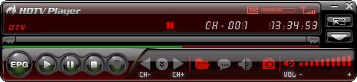

Note: The record duration depends on your TimeShift Buffer Size, which can be set in DTV Setting.

3.6 Program Guide
In EPG_Guide panel, click a program to access program details: program title, start time, end time and program description.
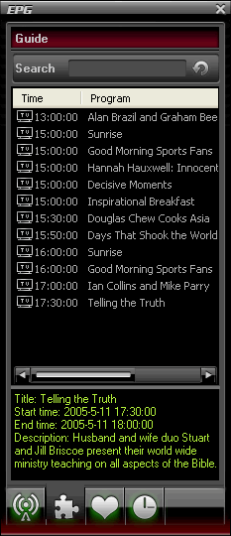
Smart Search: Type the start time or keyword of your desired programs in Search box, all the relative program guide will be displayed.
Click , you will clear the search result and resume display all the program guide.

3.7 Live Record TV Show
While you are watching a TV show, click to pop up Record floating panel, you will begin to record live HDTV show into MPEG2 file. You can also stop record, play record or delete record file in this record panel.

3.8 Create Schedule Task
- In EPG_Schedule window, click to create a task.
- In EPG_Channels window, select a program with EPG guide and click .
- In EPG_ Programs window, right click a program and select "Add to Schedule".
- In EPG_ Favorite window, select a program with EPG guide and click .
Through one of above steps to create a task and eject below Task box: here you can set task name, task type and task time.
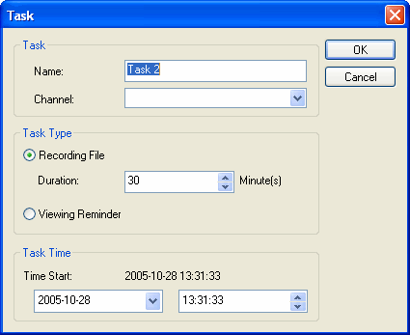
Auto wakeup to perform schedule task at PC hibernation status:
Your PC can auto wakeup to launch schedule task in hibernation status for power saving, the operation is below:
1. Set schedule task;
2. Hibernate your PC;
Note: To hibernate your PC, you must activate "Enable Hibernation" in your PC's Power Options Properties.
3. Your PC will auto wake up to perform task at the scheduled time.

3.9 Schedule Record TV Show
Following 3.8 chapter “Create Schedule Task”, set task type as “Recording File” and set task start time, it will auto record the preset TV show by the task start time, even though you are away from PC or your PC is hibernated.

3.10 Reminded to Watch
You will be reminded to watch TV show at the schedule time, thus you will never miss any of your favorite program.
Just set Task Type as Viewing Reminder when you create schedule task. The other operations are as schedule record TV.

3.11 Multi-channel Preview
- Preview while scanning channels: Tick "Preview found channels" box while scanning channels, each found channel will sequentially display on video window.
- Multi-channel preview in EPG window: Click in EPG_Channels window to refresh channels, each program will display on video window by sequence, after refresh finishes, all programs’ snapshot will be listed in EPG_Channels window. Double click a program, you will directly playback it.
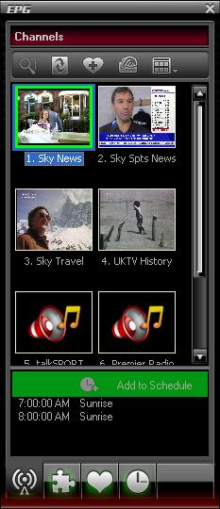

3.12 Favorite Management
- Add to favorite: In EPG_Channels window, select a channel and click or right click to add favorite.
- Watch favorite channel: double click the favorite channel to directly watch this channel's program.
- Favorite management: in EPG_Favorite window, you can freely create, rename, change or delete favorite folder.
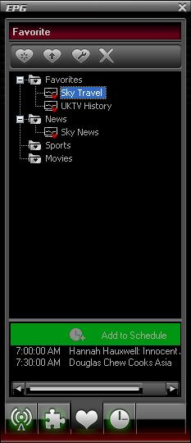

3.13 Take Snapshot
Click  to take snapshot, the captured image will display in Capture floating panel, default saved as .bmp file in "My Pictures" by sequence number 1, 2, 3, etc.
You can freely capture, preview, delete, copy or save the snapshot in Capture floating panel.
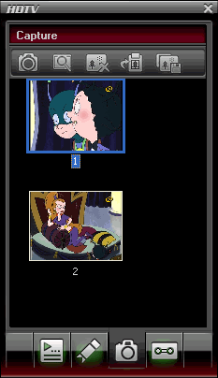

Ⅳ. Settings
Right click Video window and click Options, you will open Options box for advanced setting, below we just take DTV and Record setting as examples.

4.1 DTV Setting
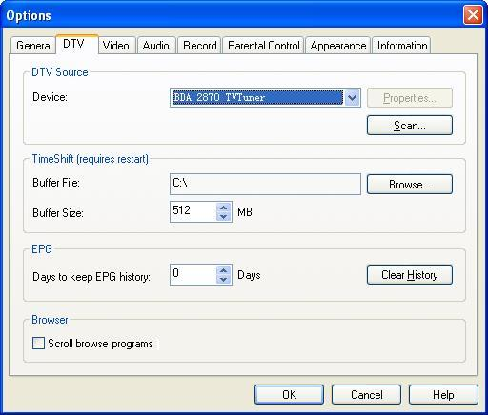
- Device: If a HDTV device installed or connected to your PC, the device name will display.
- Scan: click to launch channel scanning
- TimeShift:
  - Buffer File: display the directory of buffer file, please select a directory with large enough space.
  - Buffer Size: Hard disk size for buffer and saving paused programs, the bigger size, the longer time of saving program.
Note: After you change the buffer file or buffer size, please restart the program to activate the change.
- Days to keep EPG history: Set the days to keep the EPG history, maximum 7 days to keep EPG history.
- Clear History: Delete the EPG history.
- Scroll browse programs: Selected to scroll browse programs after click

4.2 Record Setting
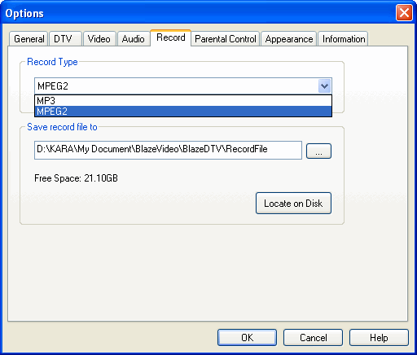

Record Type:
- MPEG2: record HDTV show/DVD movie as MPEG2 video file
- MP3: record DVD audio as MP3 audio file
Save Record File to: Specify the path to save the record file
Locate on Disk: To quickly open the record file's folder

Ⅴ. Technical Support

5.1 Troubleshooting
How to clear the saved channel:
- Please exit the program firstly, then locate “DVB_T.gsl” file in program installation folder and delete it.
Fail to search channel:
- a. Expand frequency range
- b. Adjust off-center frequency
- c. Change parameter in Advanced Setting box
Fail to playback HDTV show:
- Current channel has no data stream, please research channel.
Note: Please view the clock in Main Control Panel to check: if clock change with the time, there is data stream; clock unchanged, no data stream.
Can not record some channel’s program
- The channel adopts AC-3 audio encoding mode.

5.2. Contact Support
Please collect the following information and E-mail us. We will respond you as soon as possible:
- Product Order ID
- BlazeVideo HDTV Player’s version number
- Windows Operating System’s version
- Hardware configuration (sound card, VGA card, Image Capture card) and their specifications
- The warning message
- The time and process descriptions about your troubles.
Email: support@blazevideo.com
Web site: http://www.blazevideo.com

